
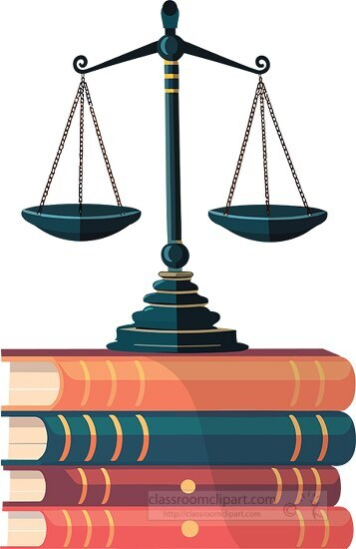

A LEVEL LAW
TRANSITION BOOKLET
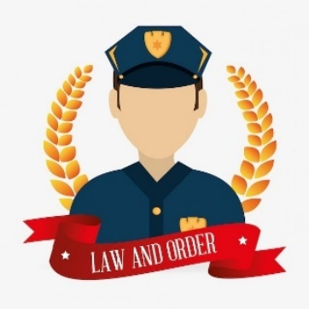
CHADWELL HEATH ACADEMY
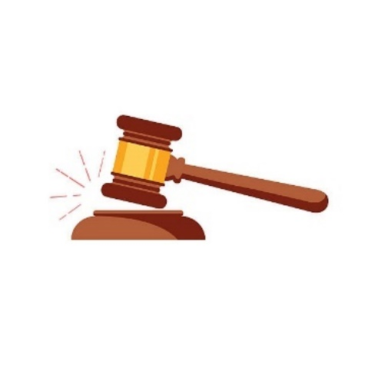

WELCOME!

Thank you for choosing to study A-Level law at Chadwell.
- When studying A-Level law you will be introduced to many areas of law such as Offences Against the Person, including murder and theft, tort law which includes occupiers’ liability and private nuisance, human rights which will include looking into international and domestic law, nature of law looking into the impacts of morality, society and justice, and many other topics.
- The exam board we follow at Chadwell Heath Academy is OCR A level Law.
- Please bring your Transition Booklet to your first law lesson in September.

TASKS!
Use this booklet to help give you an insight into some of the basics that need to be known before your studies start.

A-LEVEL LAW - TASK ONE
Research the following key terms and fill out the table below.

KEY TERM | WHAT IT MEANS?
Actus reus
Mens rea
Strict Liability
Claimant
Victim
Defendant
Negligence
Magistrates
Inchoate offence
Ratio decidendi
Member state
International law
Domestic law

A-LEVEL LAW - TASK TWO
- Put the words/statements in the correct column.

Claimant, Defendant, Court of Appeal, Magistrate’s Court, Crown Court , Guilty , Not guilty , House arrest, Liable, Tribunal, Prison
Sentencing, Unfair dismissal, Injunction, Victim, Defendant
 | CRIMINAL | CIVIL

2. What are examples of criminal offences.
  - ___________________________________________________________________
  - ___________________________________________________________________
  - ___________________________________________________________________

3. What are examples of civil law.
  - ___________________________________________________________________
  - ___________________________________________________________________
  - ___________________________________________________________________

A-LEVEL LAW – TASK THREE
Helpful websites:
https://www.tutor2u.net/law https://lawbore.net/
QUESTIONS:
Q1. Criminal offences in the UK are classified into three different categories what are they?
- ________________________________________________________________
- ________________________________________________________________
- ________________________________________________________________

Q2. What is a summary offence?
___________________________________________________________________________ ___________________________________________________________________________ Q3. Where are summary offences heard? Which court hears these cases?
___________________________________________________________________________ ___________________________________________________________________________
Q4. What is a triable either way offence?
___________________________________________________________________________
___________________________________________________________________________ Q5. Where are triable either way offences heard? Which court hears these cases?
___________________________________________________________________________
___________________________________________________________________________
Q6. What is an indictable offence?
___________________________________________________________________________
___________________________________________________________________________
Q7. Where are indictable offences heard? Which court hears these cases?
___________________________________________________________________________
___________________________________________________________________________

Using the information below categorise each offence in the most appropriate classification box.

Murder | Actual bodily  harm | Exceeding the speed  limit in a motor vehicle
Manslaughter | Criminal damage  under £5,000 | Robbery
Common assault | Watching TV  without a licence | Selling alcohol  to under 18s
Taking (a motor vehicle) without  owner’s consent | Acts of terrorism | Urinating in a  public place
Theft | Grievous bodily  harm | Burglary
Summary | Triable ‘either-way’ | Indictable

A-LEVEL LAW – TASK FOUR
A Magistrate or a judge will provide a sentence for a crime committed. There are many things they need to consider such as do they want to protect the public or do they want to punish the offender?

Answer the following questions in full sentences.
- What is a sentence?
___________________________________________________________________________
___________________________________________________________________________ ___________________________________________________________________________ 2. When is a sentence imposed?
___________________________________________________________________________
___________________________________________________________________________
___________________________________________________________________________
4. What is the difference between the roles of a jury and a judge?
___________________________________________________________________________
___________________________________________________________________________
___________________________________________________________________________
5. Who makes the decision if the defendant is guilty or not guilty and why is this important?
___________________________________________________________________________ ___________________________________________________________________________

SENTENCING AIMS:
These are the 5 aims of sentencing complete the task below.
Aim | Explanation | Most suitable punishment e.g. prison
Punishment
Reduce crime
Protection of the public
Reparation
Reform/
Rehabilitation

A LEVEL LAW – TASK FIVE
Pressure groups are organisations made up of people who share a common interest or aim. Their goal is to influence laws and government decisions. They use various methods to do this, including protests, petitions, and publicity stunts. Many pressure groups try to persuade MPs, MEPs, and local councils to listen to their views by lobbying them directly.
Some pressure groups are very large, with thousands of members, and can have a big impact — for example, Greenpeace. However, smaller groups can also be very effective. The Snowdrop Campaign played a key role in bringing about the Firearms (Amendment) Act 1997 after the Dunblane school shooting. Some pressure groups also operate as charities.
There are two main types of pressure group. Cause groups promote a particular issue — for instance, Shelter campaigns for the homeless, while Stonewall campaigns for LGBTQ+ rights. Interest groups, on the other hand, represent a specific part of society. For example, the Law Society supports solicitors, and the National Farmers’ Union works to protect the interests of farmers.
Task: Find out about two pressure groups who have managed to influence parliament and get the law reformed:
Pressure group: |  | Pressure group:

A LEVEL LAW – TASK SIX
EU Member states map
Identify the Member States of the European Union on the map below:
